/Users/nesh/Documents/Repositories/ice2021/crystals/2023-07-20/50pa/case3.0 (calibration)

Segments5, basal. Seems to support TKL theory b/c it’s an inverted “U”
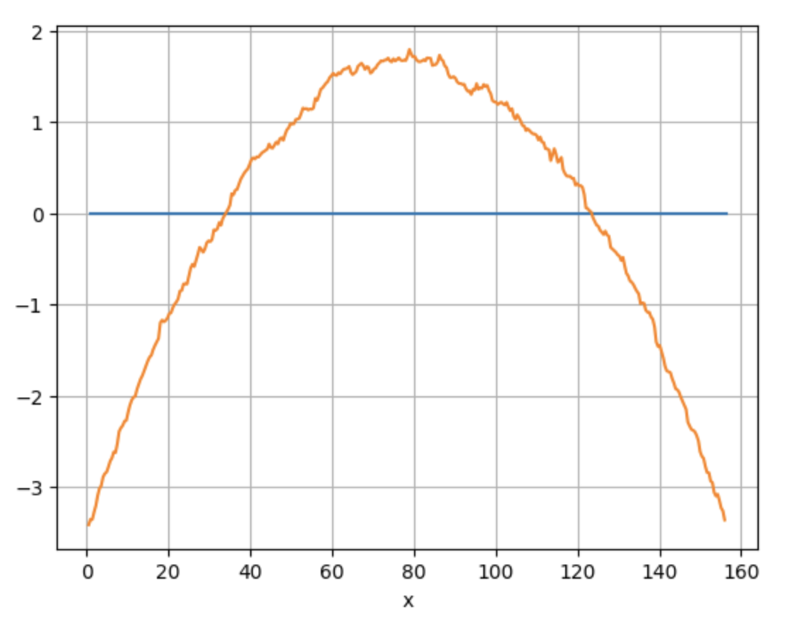

Segments1, basal. Seems to support TKL theory b/c it’s an inverted “U”



